Light + Building 2018 Innovations:
HYPRO and SIGN DIVA DANCER PLAY
Serious playmates
Neu-Goetzens, March 2018 – Modern architecture for businesses and public buildings are characterized by their representative aura. Here, a good lighting concept must support the spatial qualities, but also react flexibly to changes in use. The new, high-quality lighting systems HYPRO and SIGN DIVA DANCER PLAY by the Austrian premium manufacturer PROLICHT make both possible.

At the Light + Building fair, PROLICHT once again proves that the individualisability of its products makes the decisive difference. Thanks to the high variant configuration, the large production flexibility and the unique 25-color PROLICHT color palette, the planner can solve a wide range of lighting tasks with just one basic system. Especially in buildings for companies or public builders, there are a variety of usage scenarios for which the appropriate lighting mood can be created with the new PROLICHT solutions. Sometimes an area should receive the visitor, sometimes an area should offer orientation, at times exhibits should be staged and - last but not least - workplaces or conference rooms should be illuminated according to standards, glare-free but also representative.

Hybrid light lines
The new profile system HYPRO stands for minimalist lighting structures that can be individually configured. As a hybrid profile, HYPRO can be used for both general and accent lighting. HYPRO is available in two track widths, HYPRO 30 and 40. HYPRO 30 is available as a superstructure and pendulum version, HYPRO 40 is also suitable for flush mounting. HYPRO 40 can be integrated into both ceilings and walls, allowing it to draw lines of light, even across corner situations, and to emphasize significant design lines of building geometry.
In the system can be used adjustable spotlights and spots of different sizes with a number of different lenses and lumen packages. Furthermore, low-glare downlights, linear modules, wall washers (for example with the multifaceted Bartenbach reflectors) and modules with the new RICO reflector, which PROLICHT has developed in-house, can be integrated. With the latter, for example, workplaces can be illuminated glare-free.
Most of the inserts can be installed magnetically and repositioned without tools. The freedom of design is further increased in the version HYPRO 30 (48 Volt), in that the profile modules can be reconfigured again and again thanks to a magnet solution without tools.
For a lighting tailor like PROLICHT, it goes without saying that the exterior of the body and pendulum variants can be powder-coated in all the latest 25 colors - at no extra charge. On request, all RAL colors are also possible. A unique element is the optional COLORED CHANNEL of the HYPRO 40 profile, in which the inner cover of the channel can be finished in all PROLICHT colors. A small but subtle difference that differentiates HYPRO from many other systems.

A playful eye-catcher
Even more color configurations are possible with the revised SIGN luminaire family. The round, available in different diameters LED area lights are available with different colored lights and power cables. In addition, SIGN can be equipped with a translucent colored acrylic glass ring (KORONA SHINE) or the KORONA FRAME, a recessed diffuser combined with a lateral color edge. This allows a harmonious or even a high-contrast integration in interior concepts as desired.
The new addition to the collection is the SIGN DIVA DANCER PLAY, with which specific architectural accents can be set. With a sophisticated and patented swivel arm system, the series now has a unique adjustment feature that allows maximum flexibility on ceilings and walls. The flexible system with robust friction hinges is infinitely adjustable by 180 degrees, the articulated arm can be adjusted without tools. An optional indirect lighting completes the equipment package and allows any number of ways to make rooms with light. A whole range of new diffusers, such as SPARKLING SECRET and VINTAGE INDUSTRIAL, complete the entire SIGN family in addition to the existing opal and glare-free micro prismatic cover.
The SIGN luminaires are suitable for a wide range of applications: Office workstations, reception areas, but also catering areas benefit from the pleasant lighting atmosphere of the luminaires.

Let`s play
PROLICHT stands for creativity without limits. Ideas must be able to live. That is why PROLICHT, with its solutions such as the 2LOOK4 system, offers the opportunity to create something new every day and to play with ideas in an imaginative way. From many, many combination options, the planner at PROLICHT can create his own tailor-made product from lot size 1 onwards. This is produced by the approximately 200 employees in the heart of the Tyrolean Alps in record time - usually within five days - with passion and the highest engineering.
PROLICHT stands for tailor-made lighting with a unique lighting effect, technically sophisticated mechanics and extremely easy handling - for lighting design without compromise. This does not only apply to shops, but also to hotels, restaurants or private homes.

Reprint free of charge / specimen copy requested

Images:
You can download these and other pictures in high and low resolution under the following link at RUESS PUBLIC B::
https://filetransfer.ruess-group.com/public/fe6632

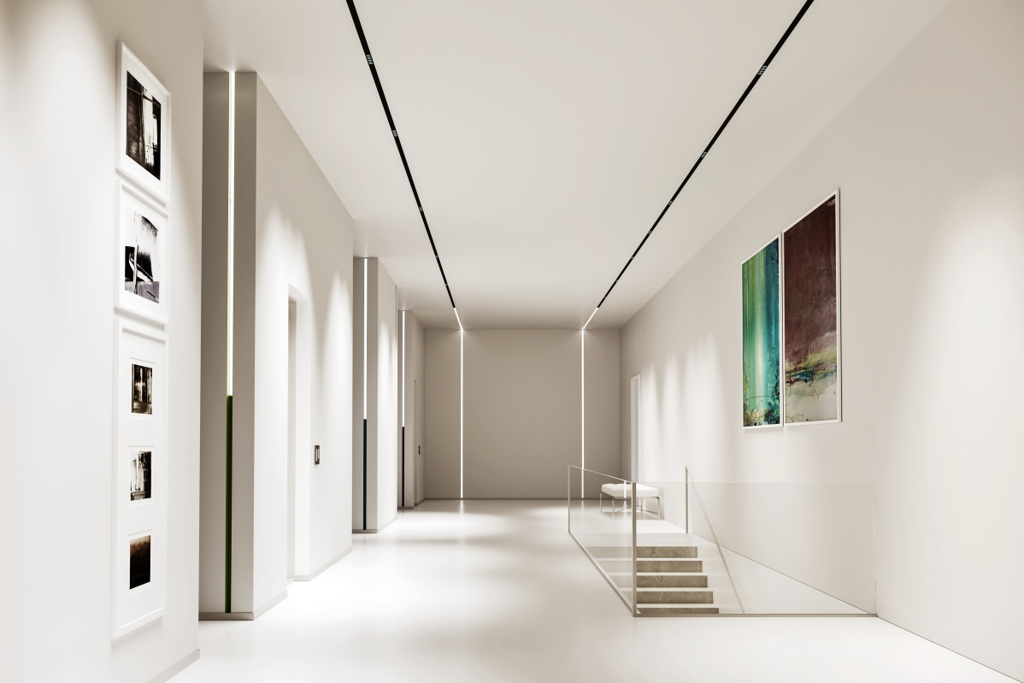
Caption: With the new HYPRO system, light lines can be drawn in space.
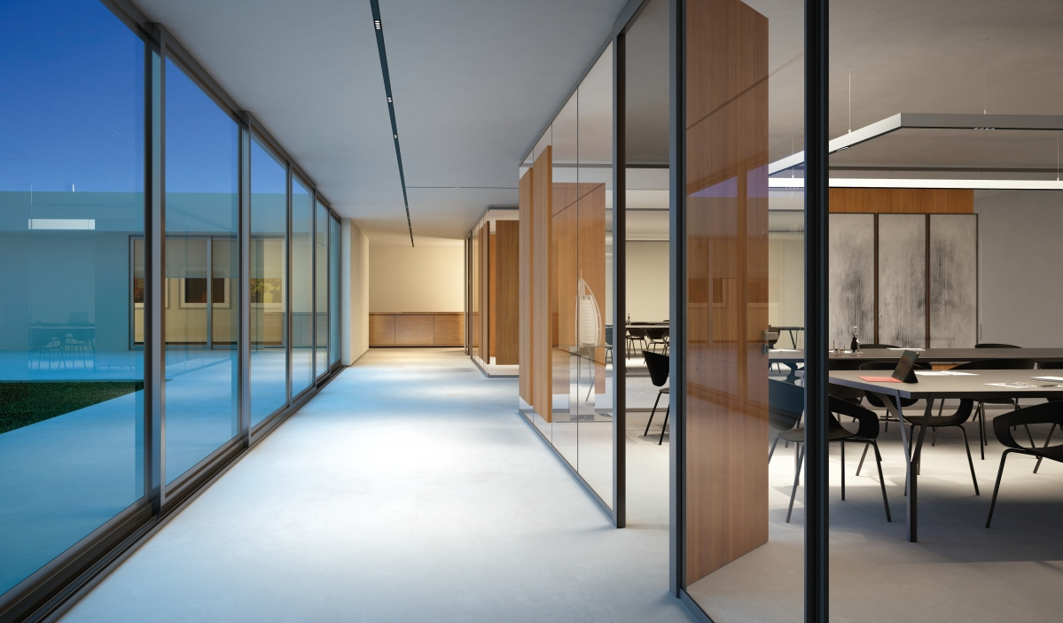
Caption: HYPRO can be equipped with various inserts and serves as a hybrid system for both general lighting and accent lighting or workplace lighting.
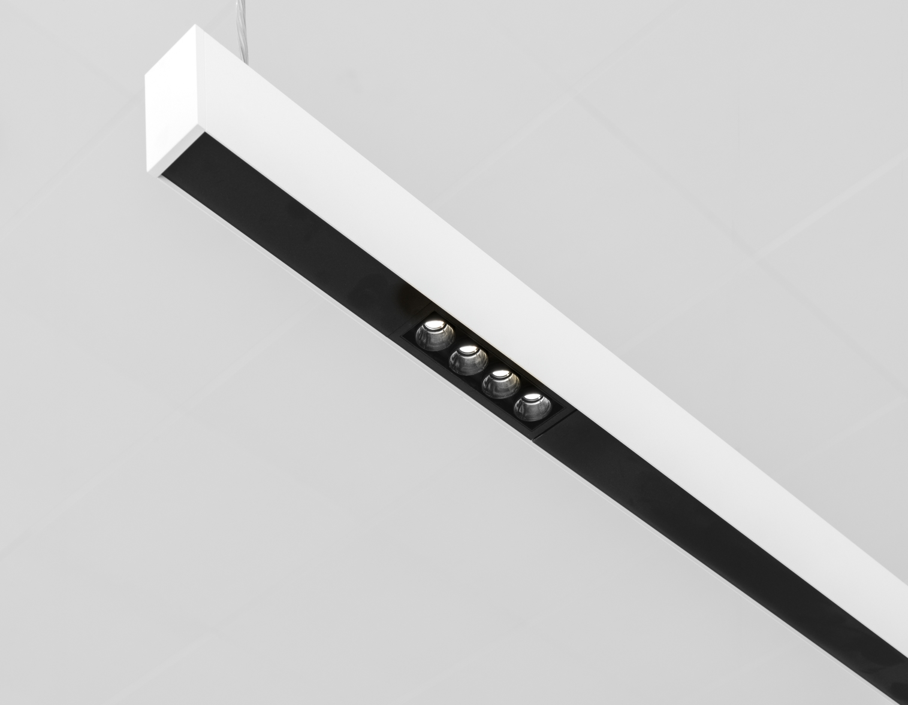
Caption: HYPRO is also available as a suspended version.

Caption: Playful eye-catcher with enormous light output: the LED lamp SIGN DIVA DANCER PLAY.
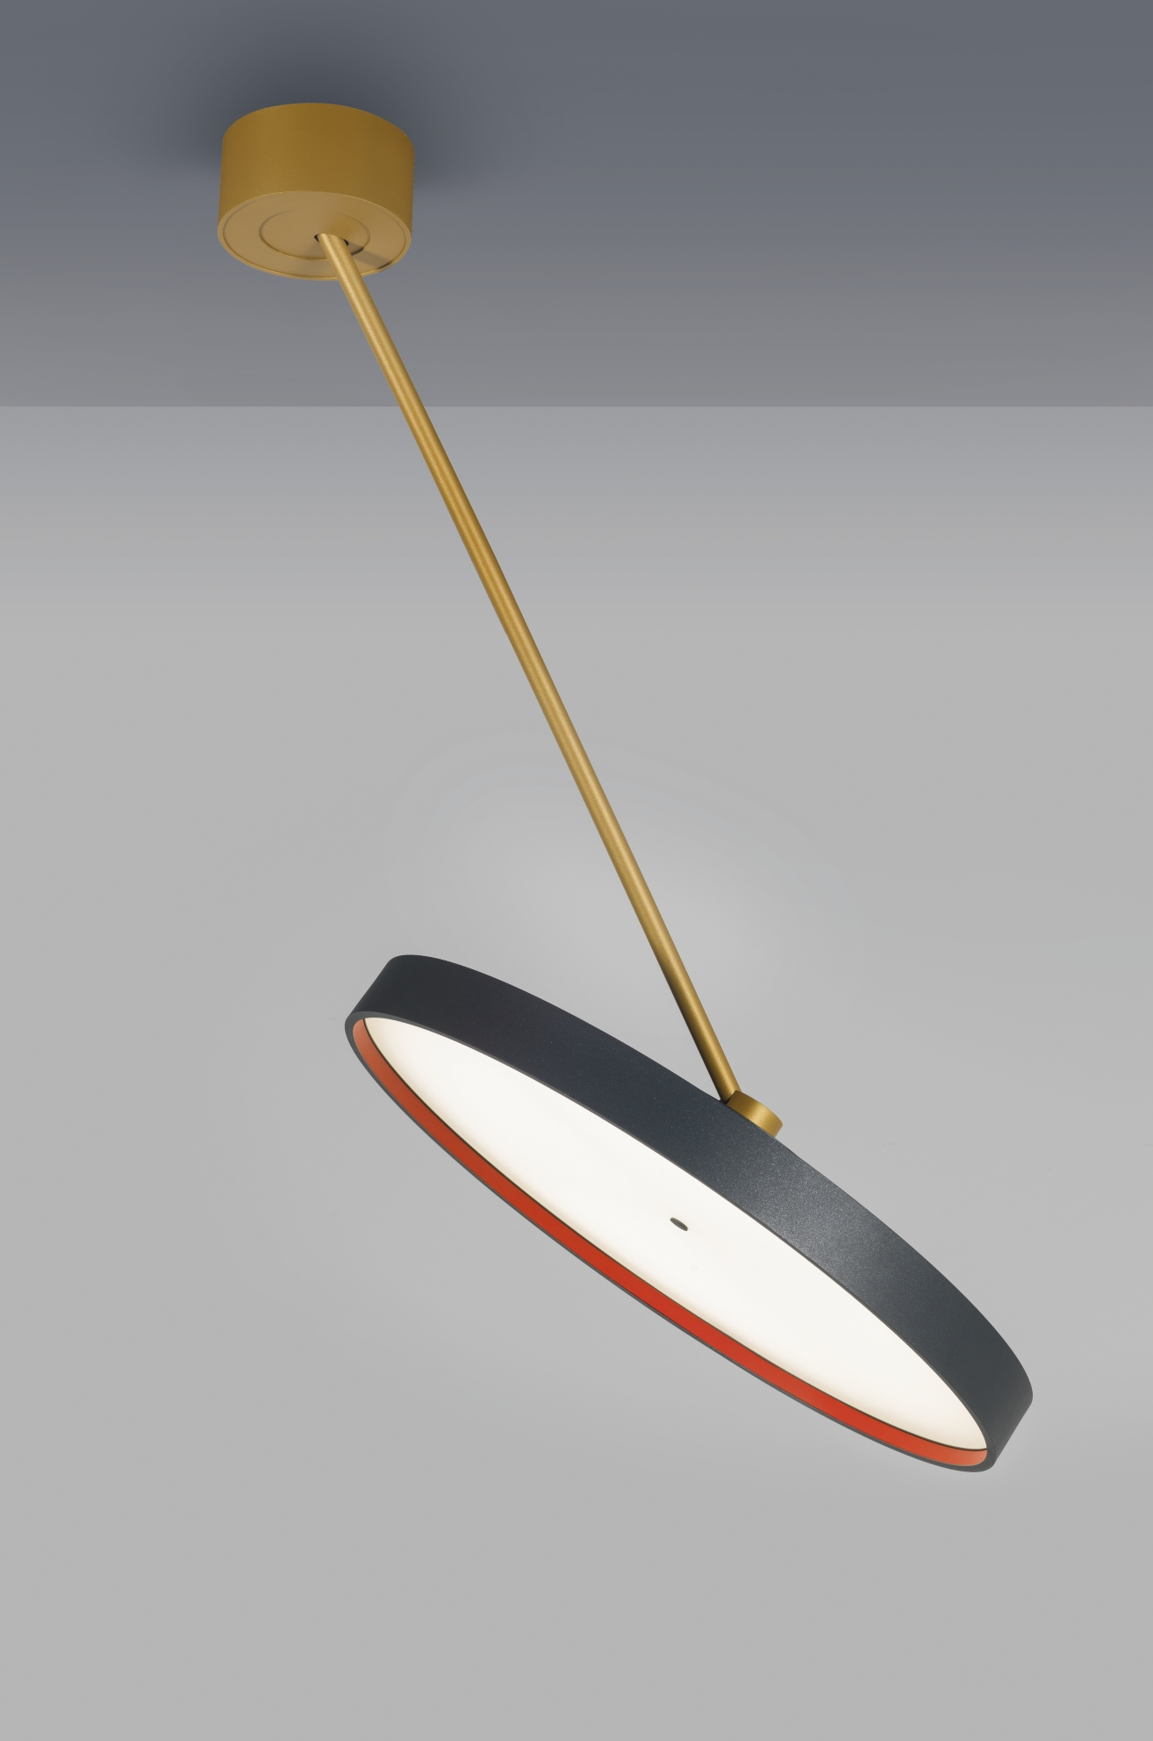
Caption: The newly developed swivel arm of the SIGN DIVA DANCER PLAY enables unusual lighting installations.
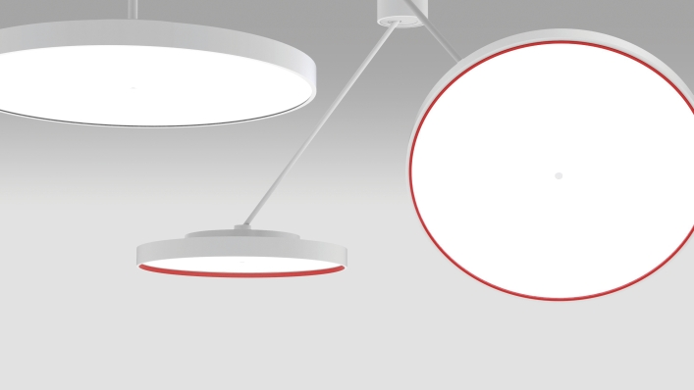
Caption: With KORONA FRAME, the planner can create a lateral color edge.

All photos: PROLICHT

About PROLICHT

PROLICHT is a worldwide successful premium manufacturer of architectural lighting concepts. Individual lighting solutions are developed and built for professional needs in record time. As an international company, PROLICHT operates the production and assembly plant at its main location in Tyrol, as well as a global sales network with partners in more than 70 countries.
The company specializes in the production of architectural luminaires and lighting systems for the shop and retail sector, offices, public buildings, hotels and restaurants. The Tyrolean company today employs around 200 people.
Efficient processes, a clear commitment to the production location Tyrol, as well as a lean organization form the basis of the economic success of PROLICHT GmbH. Ecological and social sustainability in the value chain, comprehensive product responsibility and conservation of resources are firmly anchored in the corporate strategy.

Lighting solutions that make a difference. PROLICHT

Your contact in the company:
PROLICHT GmbH
Markus Kirchmair
Marketing Director
T +43 5234 33499 27
markus.kirchmair@prolicht.at

PROLICHT GmbH
Gewerbepark 9 | A-6091 Götzens
T +43 5234 33499 38 | F +43 5234 33499 22
www.prolicht.at

